Management of Offsite Infectious Waste Transportation, Treatment, and Disposal Service Provider ‒ Guidance
Document Number: 202

Note: This guidance document is provided as a template and must be customized to accommodate facility specific procedures and terminology.

- Purpose
This guideline provides the key considerations for selecting and managing an off-site provider of infectious medical waste disposal services.

- Scope
Properly handling medical waste is crucial for minimizing the potential hazards to the health of clients, health care workers, the community and the environment. Of the total waste generated from health facilities, more than 80‒85% is nonhazardous and only 15‒20% is hazardous and /or infectious. Health care institutions need to design appropriate waste management programs comprising awareness, staff training, waste segregation, collection, transportation, disinfection and treatment. The cost of treating medical waste is a burden to resource-constrained hospitals and health systems. To minimize the burden, many health care facilities hire an off-site waste disposal service to manage disposal of their medical waste. There are significant liabilities associated with the disposal of medical waste because a legal precedent places the direct responsibility for liability on carefully selecting a qualified waste disposal service that can assure regulatory compliance.
Under the supervision of hospital staff, outsourcing medical waste disposal could be a good option and in some studies has been shown to be more cost effective than on-site treatment.

- Definitions
Off-site and outsource: Some health care facilities treat their own medical waste at on-site facilities. Others “outsource” this service, which involves hiring an external service provider with whom the health care facility enters into a contract. Outsourcing helps the health care facility to perform well in its core competencies and thus mitigates skill or expertise shortages in the areas where it wants to outsource. In either case, the director of the health care facility is responsible for the safe transport and disposal of the facility’s medical waste.

- Responsibilities
The outsourced waste disposal service provider must be managed properly. The responsibilities for management of the outsourced waste disposal service provider are as follows:
  - Waste management staff shall:
- Ensure that the waste is ready for collection at the agreed upon time and place.
- Complete waste transportation manifests and other records as required.
  - Waste manager shall:
- Establish systems to monitor compliance with the agreed upon contract between health care facilities and the outsourced waste disposal service provider.
- Conduct regular and routine audits of the outsourced waste disposal service provider from collection to transportation, treatment and final disposal.
- Report back to the waste management committee on the performance of the outsourced service provider
  - Waste Management Oversight Committee shall review all contracts and the outsourced service provider’s performance evaluation to facilitate continuous improvement.
  - Senior management should ensure that appropriate and adequate medical waste management practices are in place and that all staff are trained in them and adhere to the procedures and policies. The senior management must review the outsourced service provider’s performance evaluation for selecting a qualified waste disposal service that can assure regulatory and environmental compliance.

- Materials and Equipment
None, if the hospital outsources waste transportation and disposal services. If the hospital conducts its own waste transportation to an off-site facility, see section 7.2.2 for information on transportation vehicles and containers.

- Hazards and Safety Concerns
None, if the hospital outsources waste transportation and disposal services. Outsourcing transfers hazards to the contractor. If the hospital conducts its own waste transportation and disposal services, refer to related documents. In either case (services are outsourced or hospital conducts own transport and disposal) the facility director is ultimately responsible for ensuring that the waste from the facility are appropriately handled, transported and disposed.

- Procedures
The following section excerpts some information from Prüss A, Townend WK, Management of wastes from health-care activities: teacher’s guide. Geneva: World Health Organization; 1998. 221 p.
http://www.who.int/injection_safety/toolbox/docs/en/Teachersguide.pdf
  - Selection of outsourced service provider
Some hospitals and laboratories have medical waste incinerators or autoclaves within their facilities and are able to treat, on site, most or all of the medical waste they generate. However, for facilities that do not have the capability to treat the waste they generate, it could be less expensive to contract with someone else than to install a treatment unit. Since creating stand-alone medical waste treatment facilities may not be feasible, the option of outsourcing waste disposal should be considered. Before deciding to outsource, the following should be considered:
    - The outsourced service provider should have the approval/license from the local/national department to provide the medical waste disposal service in the location.
    - The service provider should have the adequate infrastructure and capacity to collect the waste from the respective facilities as per the defined schedule and treat the medical waste correctly and in a timely manner according to local or national regulations.
    - The service provider should provide adequate trained manpower to collect medical waste across the facilities as per the defined norms, i.e., not segregating the waste at the site/facility.
    - The health care facility should enter into a formal contract agreement with the service provider for the medical waste disposal service.
    - The service provider should provide documentation of what they collect and when and how it was treated and/or otherwise disposed of.
    - Consideration should be given to the environmental suitability of the disposal methods used by the service provider and where possible, more environmentally friendly disposal methods are preferred, e.g., autoclaving and recycling versus incineration.
  - General requirements
    - The outsourced service provider shall manage all medical waste in accordance with all applicable local or national environmental regulations as well as the health care facility-specific guidelines or procedures.
    - The outsourced service provider shall develop a hazardous waste plan that identifies all procedures for the safe handling of hazardous waste in accordance with applicable regulatory requirements. The hazardous waste plan should describe the outsourced service provider’s responsibilities related to hazardous wastes and should include, but is not limited to the following:
      - Identification of those wastes classified as hazardous waste in accordance with all applicable regulations
      - Proof of registration with local/governmental authority as a generator of hazardous waste; and certification of appropriate hazardous waste training for all employees
    - The outsourced service provider shall establish and manage hazardous waste storage area(s) in accordance with the applicable regulatory requirements, or the WHO guidelines if there are no national regulations. These areas will be designed to safely store hazardous wastes. At a minimum, the outsourced service provider must visually inspect these areas weekly and document the inspections on an on-site log. The area must be equipped with adequate signage, secondary containment, and an appropriately sized and compatible spill kit. Additional requirements may be necessary in accordance with the regulatory requirements.
    - Containers of hazardous waste shall be properly labeled, stored in/on a secondary containment device, maintained in good condition and kept closed at all times and managed in accordance with the regulatory requirements.
    - The outsourced service provider is responsible for the shipment of all hazardous waste including signing all hazardous waste manifests.
    - When selecting an outsourced provider, ensure that they are able to provide all of the above and ask for documentary evidence to this effect so that you can be sure they meet your requirements.
  - Waste storage
    - Medical waste labeling
Labeling is important for the correct identification and hence appropriate and safe management of medical waste. It acts as a warning sign to all health care workers, patients and the public about the existence of the waste. All labeling and signposting should be done according to international symbols and color coding. Also, a unified system for standards or codes for hazardous wastes should be followed across the health care facility.
A tag or adhesive label should be attached to the leak-proof, puncture-proof containers for easy identification. Items placed in the medical waste bag or in the sharps containers do not need to be labeled. Use indelible ink to print the label and ensure that the label is at least three inches by five inches. The label shall contain the following:
    - Name of the health care facility
    - Address
    - Date when the waste was generated or packaged
    - The medical waste symbol

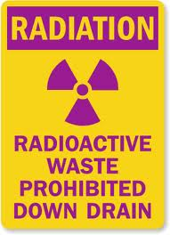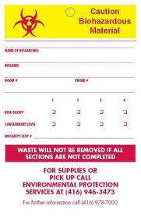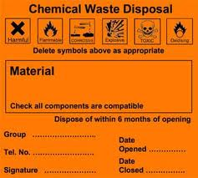
Figure1. Example of medical waste labels

When a biohazard bag, sharps container or other container is placed into a larger (secondary) container, the exterior container must be labeled in compliance with the above information.
    - Special packing requirements for off-site transport
In general, the medical waste should be packaged in sealed containers, to prevent spilling during handling and transportation. The containers should be appropriately robust for their content (puncture-proof for sharps, for example, or resistant to aggressive chemicals) and for normal conditions of handling and transportation such as vibration or change in temperature, humidity, or atmospheric pressure.
    - Regulation and control system
The medical waste producer is responsible for safe packing and adequate labeling of waste to be transported off-site and for authorization of its destination. Packing and labeling should comply with national regulations governing the transport of hazardous wastes, and with international agreements if waste are shipped abroad for treatment. In case there are no such national regulations, responsible authorities may refer to:
United Nations Economic Commission for Europe [Internet]. UN recommendations on the transport of dangerous goods, 2001 [cited 2013 April 1]. Available from: http://www.unece.org/trans/danger/publi/unrec/12_e.html
  - Waste pickup and transportation
Off-site transport (transport outside the health care facility) is the transport of the waste from the temporary storage area to the final treatment and disposal facility. This is the responsibility of the outsourced service provider if the facility does not have the capability to treat the waste it generates at the facility. (This document addresses only off-site transportation. Refer to Doc 503: On-site Handling and Transport of Infectious Waste for Housekeeping Staff for guidance on on-site transportation.)
    - Preparation for transportation
Before transportation of the medical waste, dispatch documents should be completed, all arrangements should be made between consignor, carrier, and consignee. In general medical waste should not be exported because it is hazardous waste and transboundary movements are strictly limited under the Basel Convention (www.basel.int) and the Bamako Convention for Africa. However, in exceptional circumstances, this may be justified. If so, the consignee must conform with the rules of the Convention, including confirming with the relevant competent authorities that the medical waste can be legally imported and that no delays will be incurred in the delivery of the consignment to its destination.
    - Transportation vehicle or containers
Waste bags may not be placed directly into the transportation vehicle, but must be placed in containers (e.g., wheeled, rigid, lidded, plastic or galvanized bins). Any vehicle used to transport medical waste should fulfill the following design criteria:
        - The body of the vehicle should be of a suitable size commensurate with the design of the vehicle, with an internal body height of 2.2 meters.
        - There should be a bulkhead between the driver’s cabin and the vehicle body, which is designed to retain the load if the vehicle is involved in a collision.
        - There should be a suitable system for securing the load during transport.
        - Empty plastic bags, suitable protective clothing, cleaning equipment, tools, and disinfectant, together with special kits for dealing with liquid spills, should be carried in a separate compartment in the vehicle.
        - The internal finish of the vehicle should allow it to be steam-cleaned, and the internal angles should be rounded.
        - The vehicle should be marked with the name and address of the waste carrier.
        - The international hazard sign should be displayed on the vehicle or container, as well as an emergency telephone number.

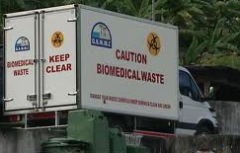
Figure 2. A vehicle used for the transportation of biomedical waste

Vehicles or containers used for the transport of medical waste should not be used for the transport of any other material. They should be kept locked at all times, except when loading and unloading. Articulated or demountable trailers (temperature controlled if required) are particularly suitable, as they can easily be left at the site of waste production. Other systems may be used, such as special designed large containers or skips; however, open-topped skips or containers should never be used for transporting medical waste.
Where the use of a dedicated vehicle cannot be justified, a bulk container that can be lifted on to a vehicle chassis may be considered. The container must be puncture-proof, leak-proof, labeled and sealed. The container may be used for storage at the health care establishment and replaced with an empty one when collected. Refrigerated containers may be used if the storage time exceeds the recommendations or transportation times are too long. The finish of these bulk containers should be smooth and impervious and permit easy cleansing or disinfection.
The same safety measures should apply to the collection of hazardous medical waste from scattered small sources.
Health-care establishments that practice minimal programs of medical waste management should either avoid off-site transportation of hazardous waste or at least use closed containers such as lidded bins to avoid spillage.
    - Routing
Medical waste should be transported by the quickest possible route, which should be planned before the journey begins. After departure from the waste production point, every effort should be made to avoid further handling. If handling cannot be avoided, it should be pre-arranged and take place in adequately designed and authorized premises. Handling requirements can be specified in the contract established between the waste producer and the carrier.
    - The control strategy for medical waste transport should have the following components:
        - A consignment note should accompany the waste from its place of production to the site of final disposal. On completion of the journey, the transporter should complete the part of consignment note especially reserved for him or her and return it to the waste producer.
        - The transporting organization should be registered with, or known to, the waste regulation authority.
        - Handling and disposal facilities should hold a permit, issued by a waste regulation authority, allowing the facilities to handle and dispose of medical waste.
The consignment note should be designed to take into account the waste control system in operation within country (see Attachment 11.1 for the example of the filled consignment form).
If a waste regulation authority is sufficiently well established, it may be possible to pre-notify the agency about the planned system of transport and disposal of the medical waste and obtain the agency’s approval.
  - Off-site treatment and disposal
Off-site treatment and disposal may be carried out in a number of ways. See the related document on waste treatment facilities for options; treatment technologies must also meet national standards. If waste is being landfilled, it must be deposited in an engineered landfill, and should be buried in a specific area and covered daily. The facility must have an up-to-date license and provide documentation that the waste has been treated and disposed of according to agreed-upon standards. The responsibility for the proper treatment and disposal of waste remains with the director of the health care facility.
  - Contract management and oversight
    - Contract management
It is essential that the HCWM contract language be explicit and comprehensive. It should outline the obligations of the contractor (health care facility) and the contractee (service provider), the tasks to be performed, as well as details of remuneration and legal liabilities. See Attachment 11.3 for an example Medical Waste Service Level Agreement.
The primary responsibility for contract execution and administration usually rests with the requisitioning department or procurement office at the health care facility. This involves periodic, ongoing contract monitoring to check that the obligations of the contract are met by the service provider.
    - Oversight and monitoring
The monitoring process should consist of:
        - Inspection of the records of waste collected and treated to ensure that the requirements are being met.
        - The right to perform evaluations not only at set intervals during the term of the contract but also at any time and from time to time at the discretion of the health care facility.
        - The right to update performance standards.
        - The right to obtain copies of the service provider’s legal registration/license to provide medical waste services.
        - The right to compel the outsourced service provider to take corrective action to remedy deficient work and the right to prohibit inadequate inappropriate or improper work.
        - The right to impose, in addition to other remedies, damages for the outsourced service provider’s failure to meet performance expectations, including the timeliness of such performance.
The responsible department shall summarize all reviews of contract and the outsourced service provider’s performance evaluation to health care facility management for review to facilitate continuous improvement.
The duration of contracts can vary depending on the needs of the health care facility or the nature of the service concerned. The standard duration for the outsourced vendor in the area of facilities management, for example, is often three years, renewable for another two years subject to satisfactory performance.

- Reporting and Recordkeeping
  - The contract, all amendments, payment schedules, and related records and must be kept on file for traceability. No matter which department is responsible for negotiating the contracts, copies will also be lodged with the Waste Management Oversight Committee.
  - Waste consignment notes should accompany every waste shipment (see Attachments 11.1 and 11.2 for examples). In addition, a simple log may be kept and a summary report made on a regular basis (usually monthly) for consideration by the waste management committee.

- References
  - United Nations Economic Commission for Europe [Internet]. UN recommendations on the transport of dangerous goods, 2001 [cited 2013 April 1]. Available from: http://www.unece.org/trans/danger/publi/unrec/12_e.html
  - A. Prüss, W. K. Townend, Management of Wastes from Health Care Activities: Teacher’s Guide. WHO, 1998. Accessed at: http://apps.who.int/iris/handle/10665/64002

- Related Documents
Doc 503: On-site Handling and Transport of Infectious Waste for Housekeeping Staff ‒ Guidance

- Attachments
  - Example Waste Consignment Note ‒ Filled
  - Example Waste Consignment Note – Blank
  - Sample Waste Service Agreement
Attachment 11.1 : Example Waste Consignment Note ‒ Filled 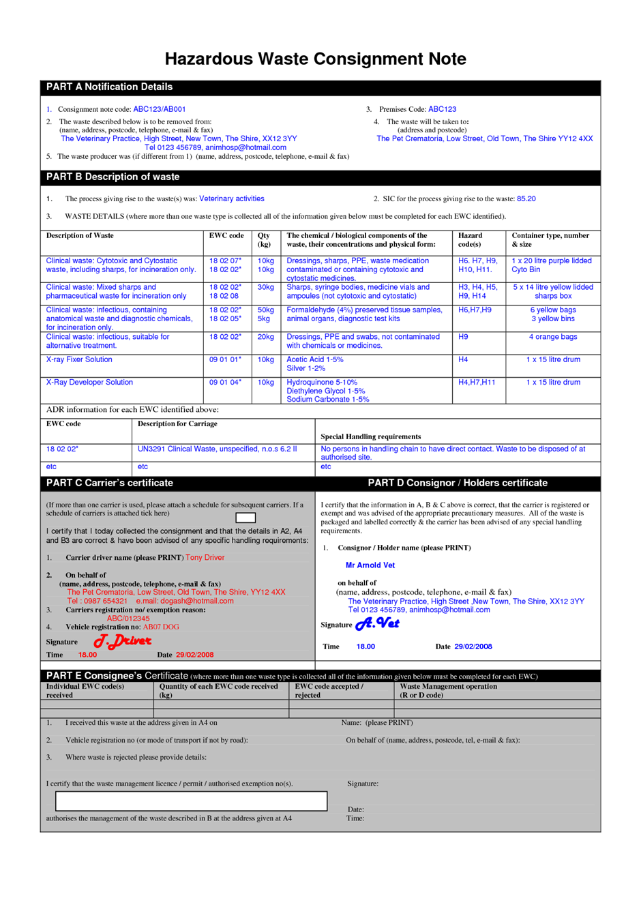
Attachment 11.2: Example Waste Consignment Note ‒ Blank

Consignment Note in accordance to ADR

Date of collection:
(Day, Month, Year)

______________________________________________________

Consignor (Generator) – name and address

______________________________________________________

Waste Carrier – name and address

Date of Receipt:

(Day, Month, Year)
______________________________________________________

Consignee (Treatment site) – name and address

Waste Description:
UN No. and type packaging | Proper shipping name | Gross weight (kg)

I hereby declare that the contents of the consignment are fully and accurately described like above by the proper shipping name and are classified packaged, marked and labeled/placarded and are in all respects in proper condition according to applicable International and National Governmental Regulations. I declare that all of the applicable requirements have been met.

_____________________ _____________________ ________________
Signature Consignor Signature Waste Carrier Signature Consignee
(Generator) (Transport)

Attachment 11.3: Example Medical Waste Service Level Agreement

MEDICAL WASTE SERVICE LEVEL AGREEMENT

between_____________________________________________________

and ________________________________________________________

Registration Number: ________________________
("The Service Provider ")
ABC HOSPITAL GROUP LTD
Registration Number

1. INTRODUCTION
1.1. The Service Provider carries on business as an integrated waste management company. The Service Provider specializes in the collection, transportation and disposal of medical waste and operates various waste disposal plants in Country X.
1.2. ABC operates medical facilities (the “facilities”) that generate medical waste of the nature specified in Annexure
1.3. ABC wishes The Service Provider to provide them with optional, medical waste collection, transportation and disposal services and The Service Provider is willing to do so on the terms set out in this agreement.

2. APPOINTMENT
ABC approves The Service Provider as a service provider for the waste collection, transportation and disposal services specified in clause 4 of the terms set out in this agreement.

3. DURATION
3.1 This agreement will commence on ___________________ and will, subject to the provisions of this agreement, continue in force and be effective for a period of 12 months (‘the period”), providing that The Service Provider remains competitive in terms of service, technology and price and retains their national license to provide such services.
3.2 Should any additional facility provide services under a sub-contract with The Service Provider during this period then the facility shall be entitled to the prices as specified in Annexure only for so long as the period may still have to run.

4. THE SERVICES
The Service Provider will provide ABC with medical waste collection, transportation and disposal services ("the services") including:
4.1. The availability of certification and approval of waste collected and destroyed as well as details of the quantities, methods and dates.
4.2 Provision of appropriate primary and/or secondary reusable and disposable containers for the storage of medical waste at and from the premises.
4.3. The collection of the medical waste from the premises and the transportation of the waste to a permitted disposal plant of The Service Provider’s choice.
4.3. The disposal of the waste at such plant.

5. OBLIGATIONS OF THE SERVICE PROVIDER
The Service Provider must:
5.1. Supply containers and items specified and priced in Annexure C ("the containers") as ABC may order from time to time within 3 days of order;
5.2. Provide the certified medical waste collection vehicles and all certified plant, equipment and personnel necessary for the collection, transportation and disposal of the waste;
5.3. Collect the waste from the premises on the days and at the frequency specified in Annexure A which may be amended from time to time as agreed by ABC.
5.4. Obtain all licenses, permits and approvals necessary for the provision of the services and comply with all applicable laws, by-laws and regulations relating to the provision of the services, with particular reference to safety containers, transport and disposal;
5.5. Take actions necessary to prevent, promptly counter and deal with any accident, spills, environmental contamination or potential threat to health which may occur during the transportation or disposal of the waste;
5.6. Provide ABC with a closed loop waste manifest document system confirming that the collected weight of the medical waste has been safely disposed of in accordance with the provisions of all applicable laws;
5.7. At any time during the performance of the services, permit an authorized employee of ABC reasonable access to the plant for the purpose of inspecting and auditing the operating procedures at the plant;
5.8 Weigh the waste at the point of collection and issue a printed receipt.
(This weight is to reconcile with the disposal and invoiced weight)
5.9. For the duration of this agreement, maintain public liability insurance with the minimum cover per event of X (actual value to be locally determined based on liability legislation);
5.10 Supply reusable sterile containers at no cost to ABC.
5.11 Supply a tracking system ( bar code , chip or similar) to reconcile and identify the container and to record that the contents that have been collected from ABC and disposed of by the Service provider;
5.12 Shall ensure that all the Service Provider’s staff are fully trained in the risks associated with Medical Waste removal and that the staff wear adequate protective safety clothing as stipulated at all times.
5.13 Arrange for periodic “swab tests” to be carried out on the re-usable containers to confirm sterilization and to copy the results to the person responsible for infection control within the Service Provider organization.

6. OBLIGATIONS OF ABC
ABC will:
6.1. Ensure as far as reasonably possible that only waste of the nature specified in Annexure is packed in the approved containers.
6.2. Obtain The Service Provider's prior written consent to any significant change in the nature of the waste prior to The Service Provider being required to collect such waste, which consent shall not be unreasonably withheld;
6.3. Enable The Service Provider to comply with its requirements under its operating permit conditions, to eliminate as far as possible the following from the waste:
6.3.1 Any drug with a high chlorine content;
6.3.2 Cyto-toxic material;
6.3.3 Polyvinyl chloride (PVC); and
6.3.4 Metal.
6.4. Eliminate as far as reasonably possible aerosol cans from the waste stream.
6.5. Carefully pack, seal and lock (where applicable) all waste in the approved containers so that the waste can be safely handled, transported and disposed of by an approved process. Sharps shall at all times be sealed in containers specifically provided for safe containment and disposal.
6.6. Ensure that any waste containing blood, plasma or human fluids is contained using a double bagging system or leak-proof buckets;
6.7. Use all reasonable efforts to promptly advise The Service Provider of any unusual potentially hazardous situation that may arise in relation to the provision of the services or any fact or circumstance which is or may be material to any method of handling, transporting or disposing of the waste or which could give rise to any claim of any nature against The Service Provider.
6.8. Endeavor as far as reasonably possible to assist The Service Provider to promptly counter and deal with any accident, spill, environmental contamination or potential threat to health which may occur on the premises during the loading by The Service Provider of the waste;
6.9. Permit The Service Provider reasonable access to the premises to perform the services.

7. REMUNERATION
7.1. ABC shall remunerate The Service Provider in accordance with the per kilogram charges specified in Annexure ("the remuneration") which shall be inclusive of collection, transport and disposal.
7.2. The remuneration excludes local taxes which, ABC shall pay to The Service Provider at the applicable rate.
7.3 The Service Provider undertakes to maintain the agreed tariff as per Annexure . Thereafter the parties may agree to an annual renewal and an annual increase which shall not exceed X.
7.4 Any increase contemplated in 7.3, shall only come into effect after written notification of the intention of The Service Provider to increase such prices of not less than one calendar month and the acceptance of these increases by the Customer.

8. PAYMENT
8.1 At the end of each month, The Service Provider will furnish ABC with an original invoice which sets out the remuneration payable by ABC for services rendered by The Service Provider during that month. Invoices will show separately, the collected weight and the disposed weight for each container.
8.2. ABC will make payment to The Service Provider within 30 days of receipt of Statement and shall do so by way of cheque or electronic bank transfer to such bank account as The Service Provider may notify ABC from time to time.
8.3. If ABC fails to pay any amount due by any individual facility (the outstanding amount”) to The Service Provider in terms of this agreement by the due date for payment:
8.3.1 The Service Provider may charge ABC interest on the outstanding amount at the prime overdraft rate offered by The Service Provider’s bankers from time to time;
8.3.2 Without prejudice to any of its rights in terms of this agreement, withhold collection of any waste from that particular facility if and for so long as the Facility fails to pay any outstanding amount; provided that The Service Provider will give ABC not less than 14 days written notice of its intention to withhold collection.
8.4 ABC is entitled to a 2.5% settlement discount for accounts settled within 30 days of the statement date.

9. RISK AND OWNERSHIP
Subject to ABC having complied with their obligations under this agreement, ownership of all risk in and to the waste will pass from ABC to The Service Provider upon handing over of the waste to The Service Provider.

10. INDEMNITIES
10.1 ABC indemnifies The Service Provider against all loss, liability, damage, expense and cost which The Service Provider may suffer as a result of or which may be attributable to any negligent act or omission by ABC , their officers, employees or agents, which breaches this agreement in any way
10.2 The Service Provider indemnifies ABC against all loss, liability, damage, expense and cost which ABC may suffer as a result of or which may be attributable to any negligent act or omission by The Service Provider, its officers, employees or agents, who breach this agreement in any way.

SIGNED AT THIS THE DAY OF 2012 SIGNED AT THIS THE DAY OF 2012
................................................... ...............................................
THE SERVICE PROVIDER ABC

AS WITNESSES: AS WITNESSES:
1. ..................................... 1. .....................................
2. ..................................... 2. .....................................

SIGNED AT THIS THE DAY OF 2012 SIGNED AT THIS THE DAY OF 2012
................................................... ...................................................

