**Chemical Waste Management — Guidance**

**Document Number: 523**

*Note: This guidance document is provided as a template and must be customized to accommodate facility specific procedures and terminology.*

1. **Purpose**

The purpose of this document is to provide the guidelines for chemical waste management in a safe and environmentally sound manner that complies with all applicable federal, state and local regulations.

1. **Scope**

Health care institutions are responsible for the development and implementation of proper management practices for all aspects of the handling, storage, and disposal of chemical wastes that are generated from their health care services. This document provides information on classification of chemical wastes, proper containerization and labeling, storage, disposal and special handling procedures for various chemical wastes.

1. **Definitions**

**Decontamination** – any process for removing and/or killing microorganisms. The same term is also used for removing or neutralizing hazardous chemicals and radioactive materials.

**Disinfectant** – a chemical or mixture of chemicals used to kill microorganisms, but not necessarily spores. Disinfectants are usually applied to inanimate surfaces or objects.

1. **Responsibilities**

Chemical waste must be managed properly. The responsibilities for hazardous waste are as follows:

* 1. Laboratory workers

If laboratory workers generate chemical waste, they must be able to determine whether their chemical wastes are hazardous by using this guideline. For hazardous waste, they must identify the hazards of the waste and follow accumulation guideline, which includes labeling, storage, and handling requirements. They must know how to request collection of hazardous waste and the guidelines for disposal of chemical waste and contaminated items to the trash and/or sanitary sewer.

The following training courses should be taken by all individuals working in a laboratory and generating chemical wastes.

* Introduction to Laboratory Safety. This is initially given as a live training and there is an annual refresher course that should be provided for all related staff.
* Managing Laboratory Waste
  1. Environmental/safety programs officer

The assigned environmental/safety program officer or equivalent collects hazardous chemical waste and manages its proper disposal. The department should provide the guidance and training for laboratory workers on proper hazardous chemical waste management. The team should establish systems to monitor compliance with the agreed-upon chemical waste procedures and monitor, investigate and report any accidents with chemical waste handling. The department should conduct regular and routine audits of waste handling system.

* 1. Senior management

The senior management should ensure that appropriate and adequate chemical waste management practices are in place and that all staff are trained in them and adhere to the procedures and policies. If there are any breaches in safe chemical waste handling practices that might harm human health or the environment, the senior management team have to report these to all relevant authorities according to institutional and national regulations.

1. **Materials and Equipment**

The following waste supplies (Figure 1) should be available in the healthcare facilities.

* Chemical waste container (1-gal bottles or 19L containers)
* Chemical waste labels
* Secondary containment bins
* Satellite accumulation area sign

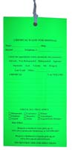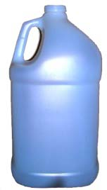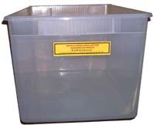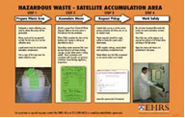

Figure 1. Waste supplies

1. **Hazards and Safety Concerns**
   1. Laboratories use a variety of toxic, corrosive, reactive and flammable chemicals that must be stored separately based on their functional classes. Components of a safe and effective chemical storage area include a maintained inventory of all chemicals stored, an anchored hazardous material storage cabinets to walls, closed and latched doors on storage cabinets, separate corrosion-free cabinets for flammable liquids, concentrated inorganic acids and caustic liquid bases, a class ABC fire extinguisher kept near locations where chemicals are stored or used (and staff trained on its operation), and a secondary containment for chemicals stored on counters and near drains.
   2. Disinfectants are toxic and undue exposure may result in respiratory distress, skin rashes or conjunctivitis. Training on proper storage, mixing and application procedures is therefore essential. If used according to the manufacturers’ instructions, and national chemical safety regulations, they are safe and effective. (See Attachment 11.1: Potential Hazards of Some Chemical Disinfectants.)
   3. Considering that chemical disinfectants are hazardous in nature, the method of disposal of the decontaminated material must be carefully chosen. Decontaminated liquid waste for example may be discharged into the public sewage system if the discharge is consistent with waste discharge requirements established by the local municipal council/regulation authority. Since disinfectants will also kill the microbes that are responsible for breaking down sewage septic tanks, care should be taken to minimize the amount of disinfectant discharged to these systems. Large, intermittent discharges can be particularly harmful and should be avoided wherever possible.
   4. Obtain MSDSs for all chemicals listing the stability, hazards and personal protection needed, as well as first aid information. This information should be available to all personnel. A 3-ring binder containing this information in one easily accessible location may be useful. MSDSs are supplied as product inserts but can also be obtained via the internet on authorized company/chemical specific websites.
   5. When decontaminating wastes using chemicals, wear appropriate personal protective equipment such as gloves, lab coats, aprons, goggles and masks. (Refer to Doc 303: HCWM Worker PPE — Guidance).
2. **Procedures** 
   1. Chemical waste classification

Chemical waste consists of discarded solid, liquid and gaseous chemicals, i.e., those generated from diagnostic and experimental work and from procedures like cleaning, housekeeping and disinfection. Chemical waste from health care services may be hazardous or nonhazardous.

A hazardous waste is a solid, liquid, or gaseous material that displays either a “Hazardous Characteristic” or is specifically “listed” by name as a hazardous waste.

Characteristic wastes are not listed specifically by their chemical name but they are regulated as hazardous wastes because they exhibit one or more hazardous characteristics outlined below.

On the other hand, the nonhazardous chemical waste consists of chemicals with none of the hazardous characteristics listed below. Examples of nonharzardous chemical waste includes distilled water, sugars, PBS buffer, amino acids, and certain organic salts.

In order to determine whether or not the chemical is hazardous, use the chemical’s original label and/or the chemical’s MSDS to determine if the waste is flammable/Ignitable, corrosive, reactive, toxic, and “persistent in the environment,” as defined below.

* + 1. Flammable/ignitable

The flammable/ignitable characteristic applies to wastes that are:

* Liquids with a flash point less than 140°F. The flash point is defined as the lowest temperature at which a chemical can form an ignitable mixture with air (for example by evaporating).
* Solids capable of spontaneous combustion under normal temperature and pressure.
* Oxidizing materials.
* Ignitable compressed gases

Examples include ethanol, sodium nitrate, hydrogen gas, xylene and acetone.

* + 1. Corrosive

The corrosive characteristic applies to wastes that are:

* Aqueous solutions with a pH less than or equal to 2 or greater than or equal to 12.5.
* This does not apply to solid or non-aqueous materials.

Examples include hydrochloric acid, nitric acid, and sodium hydroxide.

* + 1. Reactive

The reactive characteristic applies to the following:

* Materials that react violently or generate toxic fumes when mixed with water.
* Cyanide or sulfide bearing wastes which evolve toxic fumes when mixed with acids or bases.
* Materials that are normally unstable or explosive.

Examples include sodium metal, reactive sulfides, potassium cyanide and picric acid.

* + 1. Toxic

The toxic characteristic applies to wastes that have the potential to contaminate groundwater if improperly disposed of. These materials are regulated as hazardous waste due to their potential to leach out specific toxic substances in a landfill. There are currently 40 contaminants on the list that include certain heavy metals, pesticides and organic compounds. See Attachment 11.1 Contaminants for Toxicity Characteristic.

* + 1. Persistent in the environment

Persistent chemicals do not biodegrade quickly in the environment. There are two main categories of persistent chemicals, described below.

* Halogenated organic compounds

A halogenated organic compound (HOC) is a molecule that includes one or more atoms of fluorine, chlorine, bromine, or iodine. When a waste mixture contains one or more halogenated organic compounds, the total halogenated organic compound concentration is determined by summing the concentration percentages of each halogenated organic compound. If a waste mixture contains more than 0.01% HOC, the waste is persistent and therefore hazardous. For example, a waste contains 0.009% carbon tetrachloride, 0.012% DDT, and 0.020% 1,1,1-trichloroethylene. The total halogenated organic compounds concentration calculation indicates the mixture is persistent, as follows:

Total HOC Concentration = 0.009% + 0.012% + 0.020% = 0.041%

* Polycyclic aromatic hydrocarbons

The following polycyclic aromatic hydrocarbons (PAHs) are regulated: acenapthylene, acenapthene, anthracene, benzo(a)anthracene, benzo(b)fluoranthene, benzo(k)fluoranthene, benzo(q,h,i)perylene, benzo(a)pyrene, chrysene, dibenz(a,h)anthracene, indeno(1,2,3-c,d)pyrene, fluoranthene, fluorene, naphthalene, phenanthrene and pyrene. When a waste contains one or more of these PAHs, determine the total concentration by summing the concentration percentages of each regulated polycyclic aromatic hydrocarbons. If the waste contains more than 1% PAHs, the waste is persistent and therefore hazardous. For example, a waste contains 0.08% chrysene and 1.22% 3,4 -benzo[a]pyrene. The total polycyclic aromatic hydrocarbon concentration calculation demonstrates the mixture is persistent as follows:

Total PAH Concentration = 0.08% + 1.22% = 1.30%

* 1. Chemical waste containerization and labeling
     1. Appropriate containers (Figure 2)

Accumulate waste in an appropriate container compatible with the waste. The laboratory staff should ensure that the material of container is suitable for the certain kind of chemical waste. For example, if the acid waste is collected in a non-acid-resistant plastic container, decomposition of the container will possibly lead to leaks and accidents with spills.

* The containers may be reused, even containers that were used for other chemicals. If they have been rinsed and the original labels have been defaced, the container can be reused with appropriate cleaning, drying and labeling.
* Containers that were designed for solid chemicals should not be used for liquids.
* Only containers that show no sign of damage or deterioration can be reused as waste containers.
* Staff must use containers with screw top closures if at all possible. The lids of waste containers should be removed only when waste is being added to the container.
* For most large quantities of compatible liquid waste, it is recommended to use a five-gallon container; a one-gallon container is recommended for smaller volume of waste.
* Each container must have at least a one inch of headspace above the waste when it is collected; do not fill the containers completely.
* Accumulate no more than 200 liters (55 gallons) of chemical waste per waste stream or one liter of extremely hazardous waste per waste stream. Extremely hazardous waste is waste that is highly toxic, and the one liter limit is designed to limit risk, especially in the event of spill.
* Chemical wastes sent for disposal should not be mixed with biohazardous or radioactive wastes. In order to avoid explosions, fires or spills, incompatible combinations of chemicals must not be mixed in a single container (see Attachment 11.2 Chemical Waste Compatibility List).

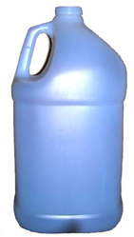 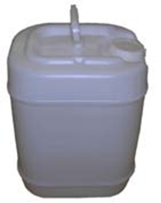

1-gallon bottle 19-Liter bottle/container

Figure 2. Example of chemical waste containers

* + 1. Properly labeling waste containers

A tag or adhesive label should be attached to the container for easy identification. Labeling is critical for the correct identification and hence appropriate and safe management of chemical wastes. It acts as a warning sign to all workers, patients and public about the existence of the waste.

Indelible ink should be used to print the label and the label should be at least three inches by five inches in size. The label shall contain the following:

* Contact information of chemical waste generator
* Waste stream
* Chemical constituents
* Hazards of the waste
* Date filled

Fill out the label completely, including percentages of constituents, the hazards of the waste, and contact name. If you do not know the hazards of your chemical, use the MSDS of the chemical to determine what they are.

Figures 3, 4, and 5 show examples of a chemical waste labels .

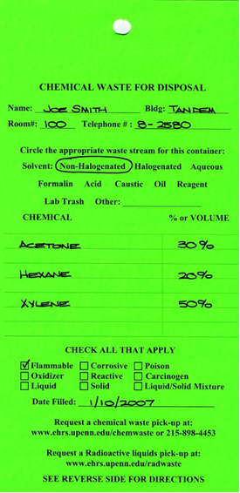

Figure 3. Example of a properly completed chemical waste label

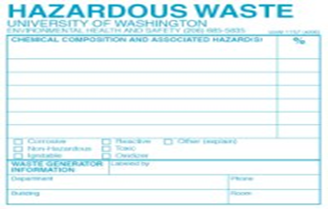

Figure 4. Example of a chemical waste label

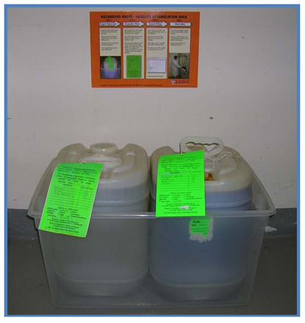

Figure 5. Chemical waste containers are labeled and placed into secondary containment waiting for pickup.

* 1. Appropriate storage

Chemical waste must be under the control of the individual(s) generating the waste. The waste should be in a physically safe area (e.g., not on a windowsill). Chemical waste must be stored away from emergency equipment such as safety showers and emergency access panels and preferably away from any source of heat, sunlight or high levels of electrical current.

* 1. Chemical waste disposal
     1. Sewer disposal

All wastewater discharged to the sanitary sewer system must be under the health care facility’s designed to protect surface waters and maintain the quality of biosolids from wastewater treatment plants. If the health care facility’s sewer limits have not been formally adopted, the operators of some very small waste treatment plants allow chemical disposal to sanitary sewer only on a case-by-case basis in order to protect the treatment plant.

* Chemical Treatment Log

All discharges must be recorded in a Chemical Treatment Log (see Doc 527: Chemical Treatment Log) if you are treating waste. Detergents, bleach and other “household” cleaning chemicals are the only exceptions to this rule and do not need to be recorded. Keep the log posted near the sink or point of discharge; the emergency phone number on the Chemical Treatment Log form must be posted in the event of an accidental release of chemicals to the sewer.

* Soaps, bleach and acetone

When the laboratory staff are washing glassware or equipment, they will likely use chemicals such as detergents and bleach. Standard household bleach and other cleansers may go down the drain. Acetone may not go down the sink at any concentration. If laboratory staff use acetone to rinse off items, they must collect any excess acetone in a securely capped, properly labeled waste container and dispose of it as hazardous waste. They may not store acetone squeeze bottles near the sink.

* Dilution prohibition

It could be illegal to dilute the chemical waste solely to meet sewer discharge limits. However, the laboratory staff may discharge to the sewer wastes such as equipment rinse water or any chemical treatment that they do as a normal part of cleaning up after an experiment, as long as it meets sewer disposal limits. There are two reasons why the laboratory staff may not dilute to meet the limits. First, if everyone were allowed to do it, the practice would use a lot of water. Secondly, many toxic chemicals, such as metals and organic compounds, partition into organic matter. At the wastewater treatment plant, these chemicals would end up in the biosolids, no matter how dilute they are. The biosolids can be re-introduced into the general environment. Therefore, it is environmentally preferable to manage concentrated wastes as hazardous waste rather than dilute to meet the discharge limit.

* + 1. Collection for disposal

Responsible staff should request collection of the chemical waste ahead of time to avoid overfilling the containers. Certain chemicals should never be mixed together because they can react with each other, leading to explosions and toxic gas release. For a list of incompatible chemicals refer to Attachment 11.2.

Chemical waste should be removed according to a regular pick up schedule established with the approved waste disposal contractor responsible for disposing of the waste. The schedule depends on the use and generation of chemicals waste. It could be weekly or monthly. The chemical waste pick-up request form should be developed and used as the record. The contact information of the waste disposal contractor should be available and updated annually.

* 1. Nonhazardous waste disposal

There are many chemical reagents and chemical products that do not meet the definition of a hazardous waste. These materials can be collected by the approved waste disposal contractor for proper disposal along with the other chemical waste streams.

* 1. Special handling by waste type
     1. Unknown materials

Without an accurate chemical name and concentration range, unknown or unidentified chemicals cannot be safely handled or disposed of. The best way to prevent unknowns is to label all chemical containers and make sure that the labels stay in good condition over time.

If there is an unknown chemical, it should be kept where it is or stored temporally in the fume hood. The responsible staff have to find out as much information as they can about the chemical such as its history and physical properties by examining the container and interviewing anyone they think might know something about the chemical. Identification analysis should be performed by the approved waste disposal contractor. After analysis, the waste disposal contractor can collect the unknown for hazardous waste disposal.

All waste of unknown chemical hazard should be regarded as highly hazardous until it has been identified as otherwise.

* + 1. Peroxide-forming chemicals

Peroxide-forming chemicals are a class of materials that have the ability to form shock-sensitive explosive peroxide crystals. Under normal storage conditions the materials listed in this section have the potential to generate and accumulate peroxide crystal formations. These formations may violently detonate when subjected to thermal or mechanical shock.

Storage and use requirements

* Do not store peroxide-forming chemicals in direct sunlight as light can accelerate the chemical reactions that form peroxides.
* If the peroxide-forming chemical is flammable and requires refrigeration, then an explosion-proof refrigerator must be used.
* Do not distill, evaporate or concentrate a peroxide-forming chemical until you have first tested it for the presence of peroxides. (Peroxides are usually less volatile than their parent material and will tend to concentrate in the hot distillation pot).
* NEVER UNDER ANY CIRCUMSTANCES touch or attempt to open container of a peroxide-forming liquid if there are whitish crystals around the cap and/or in the bottle (Figure 6). The friction of screwing the cap may detonate the bottle.

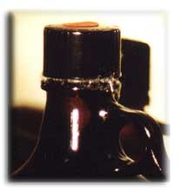 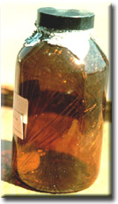

Figure 6. Pictures of dangerous peroxide crystals forming on the outside of containers.

Disposal requirements

There are three classes of peroxide-forming chemicals based upon the peroxide formation hazard:

* Class A – Severe peroxide hazard

These are chemicals that form explosive levels of peroxides without concentration. These materials should be disposed of after 6 months.

|  |  |
| --- | --- |
| Isopropyl ether | Sodium amide |
| Butadiene | Tetrafluoroethylene |
| Chlorobutadiene (chloroprene) | Divinyl acetylene |
| Potassium amide | Vinylidene chloiride |
| Potassium metal |  |

* Class B – Concentration hazard

These chemicals are a peroxide hazard on concentration (distillation/evaporation). They require external energy for spontaneous decomposition. These materials should be disposed of after one year.

|  |  |
| --- | --- |
| Acetal | Dioxane (p-dioxane) |
| Cumene | Ethylene glycol dimethyl ether (glyme) |
| Cyclohexane | Furan |
| Cyclooctene | Methyl acetylene |
| Cyclopentene | Methyl cyclopentane |
| Diacetylene | Methyl-isobutyl ketone |
| Dicyclopentadiene | Tetrahydrofuran |
| Diethylene glycol dimethyl ether (diglyme) | Tetrahydronaphthalene |
| Diethyl ether | Vinyl ethers |

* Class C – Shock and heat sensitive

These chemicals are unsaturated monomers that may autopolymerize as a result of peroxide accumulation if inhibitors have been removed or depleted. These materials should be disposed of after one year.

|  |  |
| --- | --- |
| Acrylic acid | Styrene |
| Butadiene | Vinyl acetate |
| Chlorotrifluoroethylene | Vinyl chloride |
| Ethyl acrylate | Vinyl pyridine |
| Methyl methacrylate |  |

* + 1. Waste oil

Waste oil should be collected in a proper waste container for collection. These oils are commonly found in vacuum pumps and other types of laboratory equipment. If the oils are contaminated with specific chemicals then please include this information on the chemical waste label.

* + 1. Gas-producing waste streams

Several common laboratory chemical mixtures tend to produce gas and must be stored carefully to prevent pressurizing or exploding containers.

* Aqua regia is a mixture of concentrated nitric acid (HNO3) and hydrochloric acid (HCl)
* Piranha solution is a mixture of sulfuric acid (H2SO4) and hydrogen peroxide (H2O2).

All gas-producing wastes must be stored in poly containers that have special vented caps (Figure 7). Glass containers must never be used for any gas-producing waste streams due to the risk of explosion from over-pressurization.

**p with vent opening**



Cap with vent opening

Figure 7. Special vented cap

* + 1. Compressed gas cylinders
* In general, compressed gas cylinders are the property of the vendor that delivers and replaces these units for the laboratory. Compressed gas cylinders must be returned to the vendor when they are empty or no longer needed.
* Compressed gas cylinders must be properly secured to benches or walls with appropriate strapping at all times while being stored or in use. All compressed gas cylinders must be clearly labeled with the contents.
* The mass storage of full cylinders should be in a brick built building external to the facility and away from fire. Only in-use containers should be in the facility.
  + 1. Lecture bottles

Lecture bottles (small compressed gases) are purchased through chemical supply vendors (such as Sigma Aldrich and Matheson). It is recommended that researchers attempt to purchase lecture bottles (Figure 8) from vendors who will accept partially full or empty containers when they are no longer needed in the lab.

Unwanted lecture bottles should be removed from the laboratory when they are no longer needed as they present a genuine concern for long-term storage and management.

Empty lecture bottles can also be disposed of through the approved waste disposal contractor. These bottles should be clearly labeled with the words “empty.”

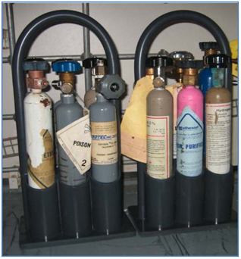

Figure 8. Lecture bottles

* + 1. Mercury-containing items

Mercury-containing items such as thermometers, thermostat switches and manometers (Figure 9) must be collected for proper disposal and not placed in the regular trash. Breaks, spills and waste disposal from these products release mercury to the atmosphere or to drains, where it can persist for many years.

Mercury clean-up guidelines

* Immediately after a spill, keep all people away from the spill area. To minimize the mercury that vaporizes, turn off any heaters, and air conditioners. Ventilate the area by opening the windows and, when possible, keep open for at least two days.
* Never use a vacuum cleaner to clean up a mercury spill. Not only will the mercury contaminate your vacuum cleaner, the heat from the vacuum cleaner will evaporate the mercury, further distributing it throughout the area. Similarly, never use a broom to clean up mercury. It will only distribute the mercury into smaller beads, and will contaminate the broom.
* Never touch the mercury.
* Assemble the necessary supplies before attempting a clean-up. These include gloves, eye protection, a syringe or eyedropper and two stiff pieces of paper or cardboard, two plastic bags, a large tray or box, packing tape, a flashlight and a wide-mouth container. Remember that any tools used for clean-up should be considered contaminated and disposed of with the mercury.
* Remove all jewelry and watches from your hands, as mercury will bond with the metal. Put on gloves, preferably rubbers gloves to minimize contact with mercury.
* On a hard surface or tightly woven fabric, use stiff paper to push beads of mercury together. Use the eyedropper to suction the beads. Carefully place the mercury in a wide-mouth container. Pick up the remaining beads of mercury with sticky tape and place contaminated tape in a plastic bag along with the eyedropper, stiff paper, and gloves. Label the bag as mercury waste. Place this bag and sealed container in the second bag. Label as mercury waste.

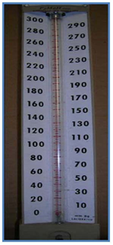 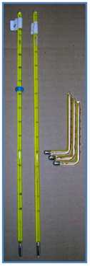

Manometer Thermometer

Figure 9. Mercury-containing items such as a manometer and thermometer

1. **Reporting and Recordkeeping**
   1. An inventory list of all stored chemicals and their related and functional storage groups should be maintained and readily available.
   2. An MSDS for all chemicals stored should be maintained and readily available.
   3. A checklist of transportation and storage requirements should be maintained and readily available.
   4. Information on appropriate protective clothing, footgear, face protection, respiratory protection, and absorbent material for liquids should be maintained and readily available.
   5. An emergency response plan that anticipates possible emergency situations should be maintained and readily available.
   6. Incidents involving chemicals during and after shipment can pose problems and should be reported and especially if persons knowledgeable in safe responses to the incident are not readily available.
   7. A staff chemical safety training program should be enforced.
2. **References**
   1. Waddell, Dave. Laboratory Waste Management Guide, Final Report. Seattle, WA: Local Hazardous Waste Management Program in King County, 2005.

<http://www.labwasteguide.org>

1. **Related documents**

* Doc 527: Chemical Treatment Log
* Doc 303: HCWM Worker PPE — Guidance

1. **Attachments**
   1. Contaminants for Toxicity Characteristic
   2. Chemical Waste Compatibility List

**Attachment 11.1: Contaminants for Toxicity Characteristic**

**EPA HW # Contaminant Regulatory Level (mg/l)**

D004 Arsenic (As) 5.0

D005 Barium (Ba) 100.0

D018 Benzene 0.5

D006 Cadmium (Cd) 1.0

D019 Carbon Tetrachloride 0.5

D020 Chlordane 0.03

D021 Chlorobenzene 100.0

D022 Chloroform 6.0

D007 Chromium (Cr) 5.0

D023 o-Cresol 200.0

D024 m-Cresol 200.0

D025 p-Cresol 200.0

D026 Cresol 200.0

D016 2,4-D 10.0

D027 1,4-Dichlorobenzen 7.5

D028 1,2-Dichloroethane 0.5

D029 1,1-Dichloroethylene 0.7

D030 2,4-Dinitrotoluene 0.13

D012 Endrin 0.02

D031 Heptachlor 0.008

D032 Hexachlorobenzene 0.13

D033 Hexachlorobutadiene 0.5

D034 Hexachloroethane 3.0

**EPA HW # Contaminant Regulatory Level (mg/l)**

D008 Lead (Pb) 5.0

D013 Lindane 0.4

D009 Mercury (Hg) 0.2

D014 Methoxychlor 10.0

D035 Methyl ethyl ketone 200.0

D036 Nitrobenzene 2.0

D037 Pentachlorophenol 100.0

D038 Pyridine 5.0

D010 Selenium (Se) 1.0

D011 Silver (Ag) 5.0

D039 Tetrachloroethylene 0.7

D015 Toxaphene 0.5

D040 Trichloroethylene 0.5

D041 2,4, 5-Trichlorophenol 400.0

D042 2,4,6-Trichlorophenol 2.0

D017 2,4,5-TP (Silvex) 1.0

D043 Vinyl Chloride 0.2

**Attachment 11.2: Chemical Waste Compatibility List**

The mixing of Group A materials with Group B materials may have the potential consequences noted.

______________________________________________________________________

**Group 1-A Group 1-B**

Acetylene sludge Acid sludge

Alkaline caustic liquids Acid and water

Alkaline cleaner Battery acid

Alkaline corrosive liquids Chemical cleaners

Alkaline corrosive battery fluid Electrolyte, acid

Caustic wastewater Etching acid liquid or solvent

Lime sludge and other corrosive alkalies Pickling liquor and other corrosive acids

Lime wastewater Spent acid

Lime and water Spent mixed acid

Spent caustic Spent sulfuric acid

**Potential consequences: Heat generation; violent reaction** ___________________________________________________________________________

**Group 2-A Group 2-B**

Aluminum Any waste in Group 1-A or 1-B

Beryllium

Calcium

Lithium

Magnesium

Potassium

Sodium

Zinc powder

Other reactive metals and metal hydroxides

**Potential consequences: Fire or explosion; generation of flammable hydrogen gas**

___________________________________________________________________________

**Group 3-A Group 3-B**

Alcohols Any concentrated waste in Groups1A or 1B

Water Calcium

Lithium

Metal hydrides

Potassium

SO2Cl2, SOCl2, PCl3, CH3SiCl3

Other water-reactive waste

**Potential consequences: Fire, explosion, or heat generation; generation of flammable or toxic gases**

**___________________________________________________________________________**

**Group 4-A Group 4-B**

Alcohols Concentrated Group 1-A or 1-B wastes

Aldehydes Group 2-A wastes

Halogenated hydrocarbons

Nitrated hydrocarbons

Unsaturated hydrocarbons

Other reactive organic compounds and solvents

**Potential consequences: Fire, explosion, or violent reaction**

___________________________________________________________________________

**Group 5-A Group 5-B**

Spent cyanide and sulfide solutions Group 1-B wastes

**Potential consequences: Generation of toxic hydrogen cyanide or hydrogen sulfide gas**

___________________________________________________________________________

**Group 6-A Group 6-B**

Chlorates Acetic acid and other organic acids

Chlorine Concentrated mineral acids

Chlorites Group 2-A wastes

Chromic acid Group 5-A wastes

Hypochlorites Other flammable and combustible wastes

Nitrates

Nitric acid, fuming

Perchlorates

Permanganates

Peroxides

Other strong oxidizers

**Potential consequences: Fire, explosion, or violent reaction**

___________________________________________________________________________